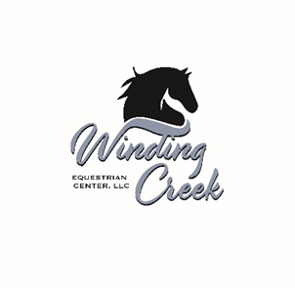

**Student Information and Liability Release Form**

Rider’s Name:____________________________________________________Date:______________________

Parent’s Name (If Minor):_____________________________________________________________________

Address:___________________________________________________________________________________

__________________________________________________________________________________________

Home Phone:_______________________________Cell:____________________________________________

Email:_____________________________________________________________________________________

Emergency Contact:__________________________________________Phone:__________________________

WHEREAS, the UNDERSIGNED acknowledges the inherent risks involved in riding and working around horses, which risks include bodily injury from using, riding or being in close proximity to horses, among other risks, and further, that both horse and rider can be injured in normal use or in competition or in schooling:

IN CONSIDERATION, therefore, for the privilege of riding and/ or working around horses at Winding Creek Equestrian Center, LLC., the undersigned does hereby agree to hold harmless and indemnify Winding Creek Equestrian Center LLC., its agents, employees and further release them from any liability of responsibility for accident, damage, injury, or illness to the Undersigned or any horse owned by the Undersigned or to any family member or spectator accompanying the Undersigned while on the premises of Winding Creek Equestrian Center, LLC. I shall bring no claims, demands, actions, and causes of action, and/or litigation, against this Equestrian Center for any economic and non-economic losses to bodily injury, death, and/or property damage sustained by me and/or my minor child or legal ward in relation to the premises and operations of this Equestrian Center, including while riding, handling, or otherwise being near horses owned by or in care, custody or control of Winding Creek Equestrian Center.

*Equine Activity Liability Act: Each participant who engages in an equine activity assumes the risks of engaging in and legal responsibility for injury, loss, or damages to person or property resulting from the risks of equine activity. IL P.W.A. #89-0111.

Photo Release-Adult: I grant permission to use my photograph in print or online materials designed for news, informational or educational purposes related to Winding Creek Equestrian Center, LLC.

Photo Release-Minor: I grant permission to use photographs of my minor child in print or online material designed for news, informational or educational purposes related to Winding Creek Equestrian Center, LLC.

